ACF Lab 2: Build a VPC and launch a Web Server

____________________________________________________

COS 20019- Cloud Computing Architecture

Nguyen Manh Dung

1/6/2023

So this is all my step to finish ACF Lab 2, belong with detailed explanation.

**Task 1: Create Your VPC**

6. Begin creating a VPC

* In the top right of the screen, verify that N. Virginia (us-east-1) is the region.
* Choose the VPC dashboard link which is also towards the top left of the console.
* Next, choose Create VPC.

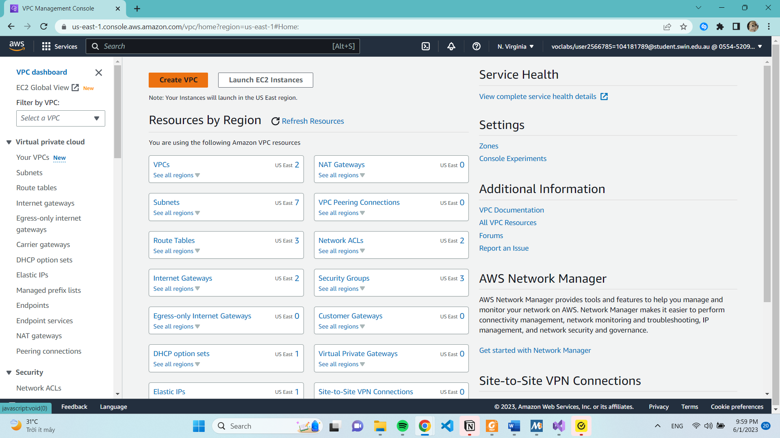

7. Configure the VPC details in the VPC settings panel on the left:

* Choose VPC and more.
* Under Name tag auto-generation, keep Auto-generate selected, however change the value from project to lab.
* Keep the IPv4 CIDR block set to 10.0.0.0/16
* For Number of Availability Zones, choose 1. A picture containing text, screenshot, software, computer icon

  Description automatically generated
* For Number of public subnets, keep the 1 setting.
* For Number of private subnets, keep the 1 setting.
* Expand the Customize subnets CIDR blocks section
* Change Public subnet CIDR block in us-east-1a to 10.0.0.0/24
* Change Private subnet CIDR block in us-east-1a to 10.0.1.0/24
* Set NAT gateways to In 1 AZ.
* Set VPC endpoints to None.
* Keep both DNS hostnames and DNS resolution enabled.

8. Confirm the settings I have configured.

* **VPC**: lab-vpc
* **Subnets:**
  + us-east-1a
* **Public subnet name**: lab-subnet-public1-us-east-1a
* **Private subnet name:** lab-subnet-private1-us-east-1a
* **Route table**
  + lab-rtb-public
  + lab-rtb-private1-us-east-1a
* **Network connections**
  + lab-igw
  + lab-nat-public1-us-east-1a

12. Choose **Create subnet** then configure:

* **VPC ID**: lab-vpc (select from the menu).
* **Subnet name: l**ab-subnet-public2
* **Availability Zone:** Select the second Availability Zone (for example, us-east-1b)
* **IPv4 CIDR block**: 10.0.2.0/24

The subnet will have all IP addresses starting with **10.0.2.x.**

To Create another subnet, Choose Create subnet then configure:

* **VPC ID**: lab-vpc
* **Subnet name**: lab-subnet-private2
* **Availability Zone:** Select the second Availability Zone (for example, us-east-1b)
* **IPv4 CIDR block:** 10.0.3.0/24

The subnet will have all IP addresses starting with **10.0.3.x.**

20-21. Edit subnet associations. -> Leave **lab-subnet-private1-us-east-1a** selected, but also select **lab-subnet-private2.**

27.

**Task 3**: Create a VPC Security Group

**30**.

Choose **Create security group** and then configure:

* **Security group name**: Web Security Group
* **Description:** Enable HTTP access
* **VPC:** choose the X to remove the currently selected VPC, then from the drop down list choose **lab-vpc**

**31. Add Inbound rule**

* **Type:** HTTP
* **Source**: Anywhere-IPv4
* **Description**: Permit web requestsA screenshot of a computer

  Description automatically generated

**Task 4: Launch a Web Server Instance**

**35-42.** Configuring Web Server Instance

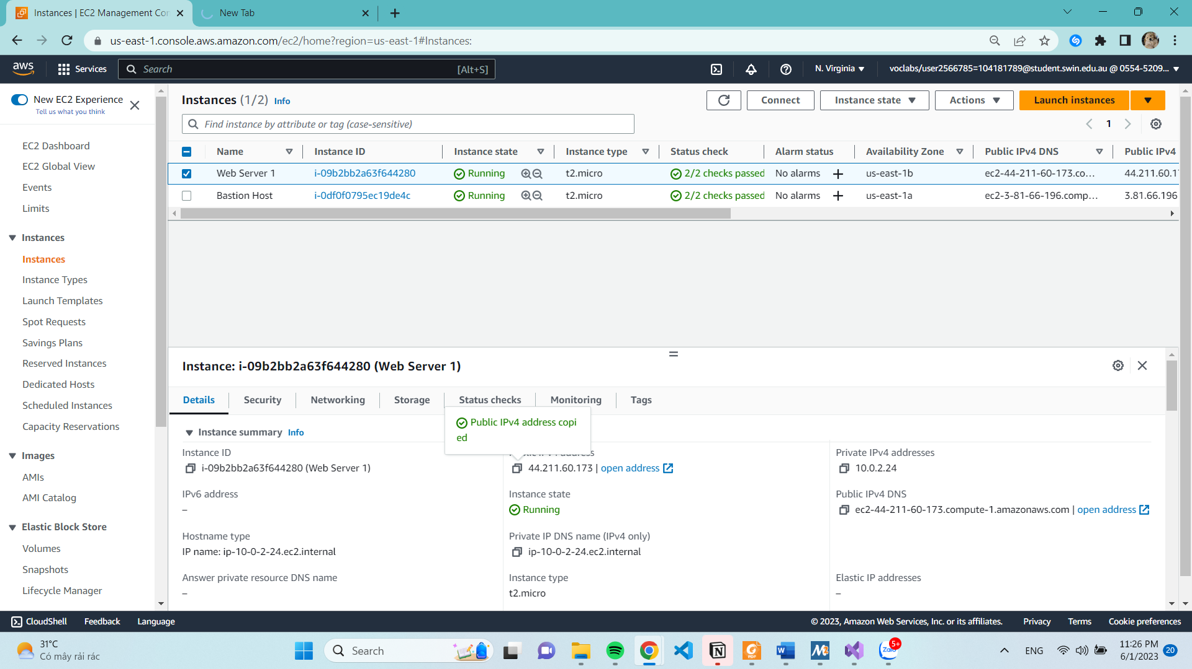

47. Copy the **Public IPv4 DNS** value then Open a new web browser tab, paste the Public DNS value and press Enter.

